数据库服务器Oracle 10g RAC for linux (裸设备）安装步骤

1 系统环境表

1.1 系统信息
nodeA
设备 IP 地址 子网 目的
eth0 192.0.2.224 255.255.255.0 连接 nodeB与外部网络
eth1 10.10.17.221 255.255.255.0 连接 nodeB-priv （互联）
VIP 192.0.2.225 255.255.255.0 虚拟IP
用户名 root 密码 roothtxx
用户名 oracle 密码 oracle
ORACLE_SID nodeA
主机名 nodeA
/etc/hosts
127.0.0.1 localhost
192.0.2.224 nodeA
192.0.2.253 nodeB

192.0.2.225 nodeA-vip
192.0.2.252 nodeB-vip

10.10.17.221 nodeA-priv
10.10.17.222 nodeB-priv
nodeB
设备 IP 地址 子网 目的
eth0 192.0.2.253 255.255.255.0 连接 nodeB与外部网络
eth1 10.10.17.222 255.255.255.0 连接 nodeB-priv （互联）
VIP 192.0.2.252 255.255.255.0 虚拟IP
用户名 root 密码 roothtxx
用户名 oracle 密码 oracle
ORACLE_SID nodeA
主机名 nodeA
/etc/hosts
127.0.0.1 localhost
192.0.2.224 nodeA
192.0.2.253 nodeB

192.0.2.225 nodeA-vip
192.0.2.252 nodeB-vip

10.10.17.221 nodeA-priv
10.10.17.222 nodeB-priv

1.2 空间分配
Nas盘共享目录/home/oracle/shared_config/下用来建ocr和votingdisk
ISCSI模拟盘阵：/dev/sdb用于建立asm

2 安装前准备的Rpm 包
Rpm 包清单
binutils-2.15.92.0.2-10.EL4
compat-db-4.1.25-9
control-center-2.8.0-12
gcc-3.4.3-9.EL4
gcc-c++-3.4.3-9.EL4
glibc-2.3.4-2
glibc-common-2.3.4-2
gnome-libs-1.4.1.2.90-44.1
libstdc++-3.4.3-9.EL4
libstdc++-devel-3.4.3-9.EL4
make-3.80-5
pdksh-5.2.14-30
sysstat-5.0.5-1
xscreensaver-4.18-5.rhel4.2
compat-libstdc
compat-libstdc++-33
compat-libstdc++-296

3 系统参数配置脚本
#echo "kernel.shmall = 2097152" >> /etc/sysctl.conf
#echo "kernel.shmmax = 4096000000" >> /etc/sysctl.conf
#echo "kernel.shmmni = 4096" >> /etc/sysctl.conf
#echo "kernel.sem = 250 32000 100 128" >> /etc/sysctl.conf
#echo "fs.file-max = 65536" >> /etc/sysctl.conf
#echo "net.ipv4.ip_local_port_range = 1024 65000" >> /etc/sysctl.conf
#echo "net.core.rmem_default=262144" >> /etc/sysctl.conf
#echo "net.core.wmem_default=262144" >> /etc/sysctl.conf
#echo "net.core.rmem_max=262144" >> /etc/sysctl.conf
#echo "net.core.wmem_max=262144" >> /etc/sysctl.conf
#echo "oracle soft nofile 4096" >> /etc/security/limits.conf
#echo "oracle hard nofile 63536" >> /etc/security/limits.conf
#echo "oracl soft nproc 2047" >> /etc/security/limits.conf
#echo "oracle hard nproc 16384" >> /etc/security/limits.conf

4 创建Oracle帐户及配置用户信息（在所有节点上执行）
/usr/sbin/groupadd oinstall
/usr/sbin/groupadd dba
/usr/sbin/useradd -s /bin/ksh -m -g oinstall -G dba oracle
/usr/sbin/useradd -d /home/oracle -s /bin/ksh -m -g dba -G oinstall oracle
需要创建以下目录
Oracle Base Directory #/u01/app/oracle
Oracle Inventory Directory #/u01/app/oracle/oraInventory
Oracle Clusterware Home Directory
#/oracle/crs
Oracle Home Directory #/u01/app/oracle/product/10.2.0/db_1
以 root 用户身份执行以下命令：
mkdir -p /u01/app/oracle
mkdir -p /u01/app/oracle/oraInventory
mkdir -p /oracle/crs
mkdir -p /u01/app/oracle/product/10.2.0/db_1
chown -R oracle:oinstall /u01
chmod -R 775 /u01

export ORACLE_BASE=/u01/app/oracle
export ORACLE_HOME=/ oracle/crs
export ORA_CRS_HOME=/u01/app/oracle/product/10.2.0/crs_1
export ORACLE_SID=testrac1
#export ORACLE_SID=testrac2 #nodeB
export ORACLE_TERM=xterm
export ORACLE_OWNER=oracle
export TNS_ADMIN=$ORACLE_HOME/network/admin
export ORA_NLS33=$ORACLE_HOME/ocommon/nls/admin/data
export NLS_LANG=AMERICAN_AMERICA.ZHS16GBK
umask 022
set -o vi
1.生成oracle和root用户的公密钥 (在所有节点执行）
root#/ssh-keygent -t rsa
root#/ssh-keygent -t dsa
#su - oracle
oracle$ /usr/bin/ssh-keygen -t rsa
oracle$ /usr/bin/ssh-keygen -t dsa
2．发布公钥和获取公钥（在nodeA节点执行）
root#echo "发布公钥和获取公钥"
root#cat ~/.ssh/id_dsa.pub > ~/.ssh/authorized_keys
root#cat ~/.ssh/id_rsa.pub >> ~/.ssh/authorized_keys
root#ssh nodeB cat /root/.ssh/id_dsa.pub >> ~/.ssh/authorized_keys
root#ssh nodeB cat /root/.ssh/id_rsa.pub >> ~/.ssh/authorized_keys
root#scp ~/.ssh/authorized_keys nodeB:/root/.ssh/authorized_keys
#su - oracle
oracle$cat ~/.ssh/id_dsa.pub > ~/.ssh/authorized_keys
oracle$cat ~/.ssh/id_rsa.pub >> ~/.ssh/authorized_keys
oracle$ssh nodeB cat /home/oracle/.ssh/id_dsa.pub >> ~/.ssh/authorized_keys
oracle$ssh nodeB cat /home/oracle/.ssh/id_rsa.pub >> ~/.ssh/authorized_keys
oracle$scp ~/.ssh/authorized_keys nodeB:/home/oracle/.ssh/authorized_keys
4.5 检查信任（全部节点执行）
[root@nodeB raw]# ssh nodeA date
Sat Dec 27 21:25:18 PST 2008
[root@nodeB raw]# ssh nodeB date
The authenticity of host nodeB (192.168.85.12)' can't be established.
RSA key fingerprint is e7:be:a8:0f:94:30:df:28:c0:25:5d:cf:4b:ce:ba:d7.
Are you sure you want to continue connecting (yes/no)? yes
Warning: Permanently added 'nodeB,192.168.85.12' (RSA) to the list of known hosts.
Sat Dec 27 21:25:29 PST 2008
[root@nodeB raw]# ssh nodeB-priv date
The authenticity of host 'nodeB-priv (172.16.85.2)' can't be established.
RSA key fingerprint is e7:be:a8:0f:94:30:df:28:c0:25:5d:cf:4b:ce:ba:d7.
Are you sure you want to continue connecting (yes/no)? yes
Warning: Permanently added 'nodeB-priv,172.16.85.2' (RSA) to the list of known hosts.
Sat Dec 27 21:25:32 PST 2008
[root@nodeB raw]# ssh nodeA-priv date
The authenticity of host 'nodeA-priv (172.16.85.1)' can't be established.
RSA key fingerprint is c4:11:89:e2:1a:92:e6:98:c7:f2:1c:c2:90:2f:f3:bc.
Are you sure you want to continue connecting (yes/no)? yes
Warning: Permanently added 'nodeA-priv,172.16.85.1' (RSA) to the list of known hosts.
Sat Dec 27 21:25:27 PST 2008
[root@nodeB raw]#su - oracle
[oracle@nodeB ~]$ ssh nodeA date
Sat Dec 27 21:26:38 PST 2008
[oracle@nodeB ~]$ ssh nodeB date
Sat Dec 27 21:26:45 PST 2008
[oracle@nodeB ~]$ ssh nodeA-priv date
Sat Dec 27 21:27:57 PST 2008
[oracle@nodeB ~]$ ssh nodeB-priv date
Sat Dec 27 21:26:53 PST 2008
在所有节点执行
#modproe hangcheck-timer
#echo "/sbin/modprobe hangcheck-timer hangcheck_tick=30 hangcheck_margin=180 " >> /etc/rc.local
#modprobe hangcheck-timer hangcheck_tick=30 hangcheck_margin=180

5. 磁盘分配
安装 Openfiler
Openfiler 由 rPath Linux 驱动，它是一个基于浏览器的免费网络存储管理实用程序，可以在单一框架中提供基于文件的网络连接存储 (NAS) 和基于块的存储区域网 (SAN)。整个软件包与开放源代码应用程序（例如 Apache、Samba、LVM2、ext3、Linux NFS 和 iSCSI Enterprise Target）连接。Openfiler 将这些随处可见的技术组合到一个易于使用的小型管理解决方案中，该解决方案通过一个基于 Web 且功能强大的管理界面实现。我仅使用它的 iSCSI 功能为 Oracle10g RAC 需要的共享存储组件实现低成本的 SAN。Openfiler 服务器将配置为使用该磁盘进行基于 iSCSI 的存储，并且将在 Oracle10g RAC 配置中用于存储 Oracle 集群件所需的共享文件以及所有 Oracle ASM 卷。
下载 Openfiler
Openfiler
Download openfiler-2.3-x86-disc1.iso (330.3 MB)
安装 Openfiler
在 VMware 建个Linux 虚拟主机，然后直接用镜像进行安装, 安装方法跟Linux 的安装一样.
Boot Screen
第一个屏幕是 Openfiler 引导屏幕。在 boot: 提示符处按 [Enter] 键启动安装过程
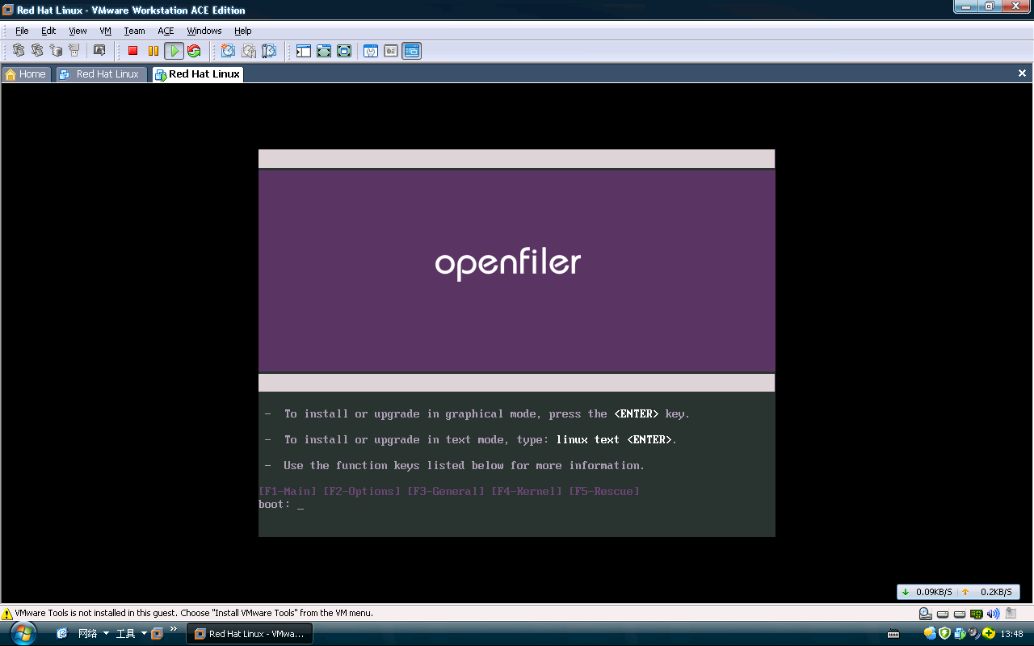
Disk Partitioning Setup
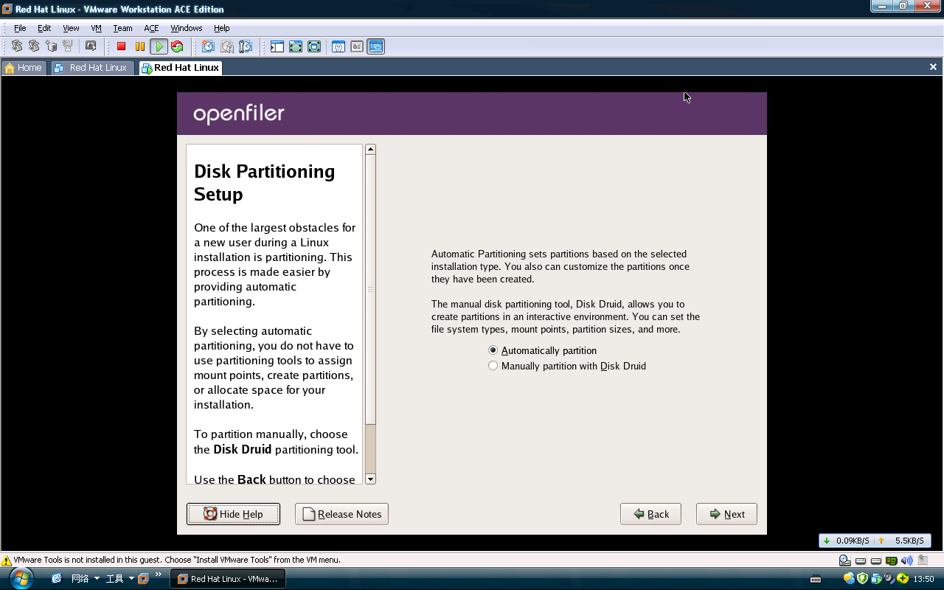

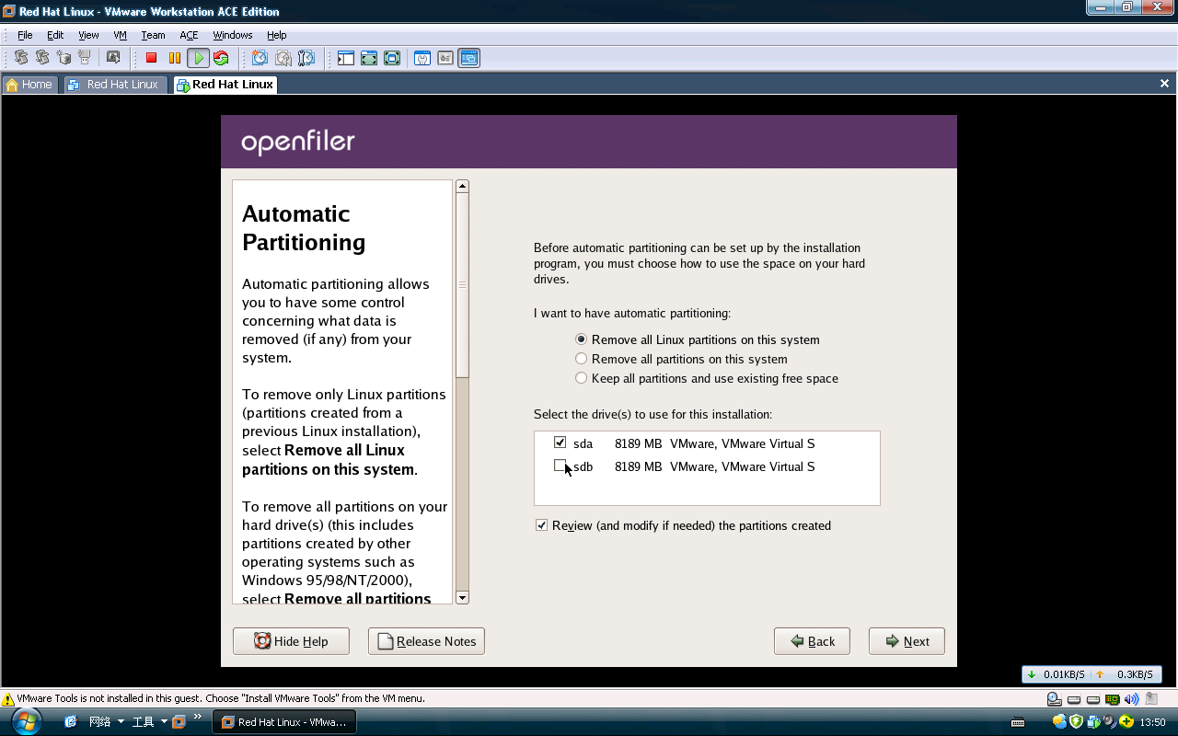
Network Configuration
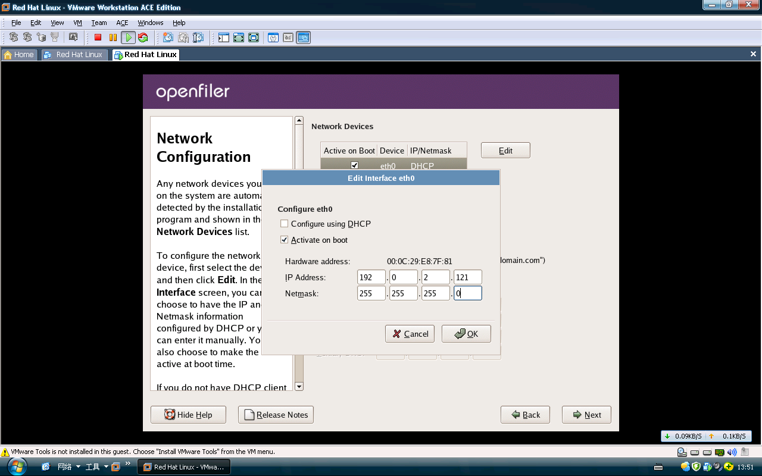
Time Zone Selection
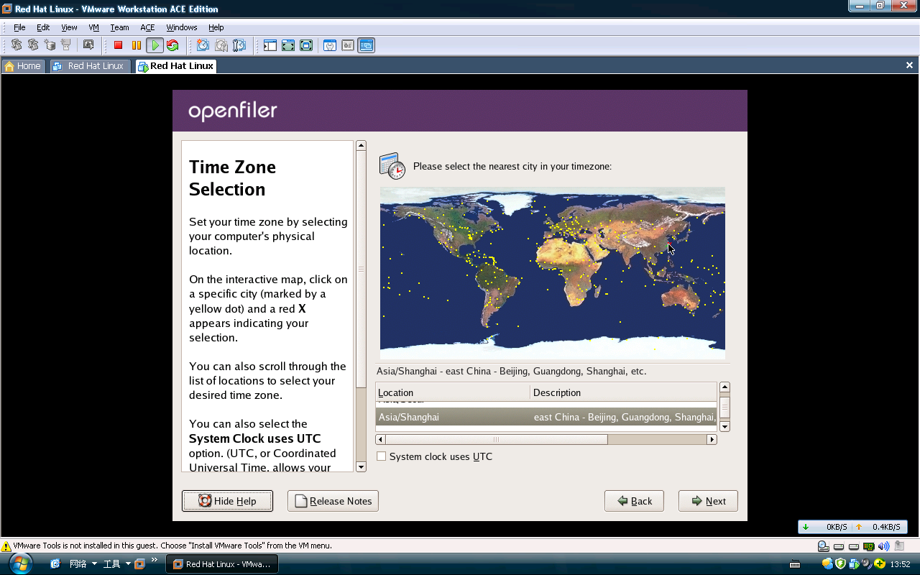
Set Root Password
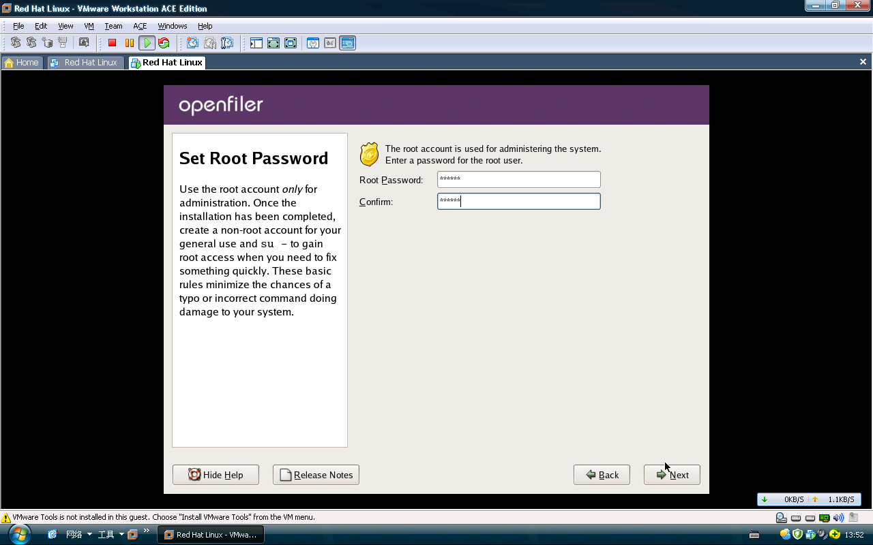
About to Install
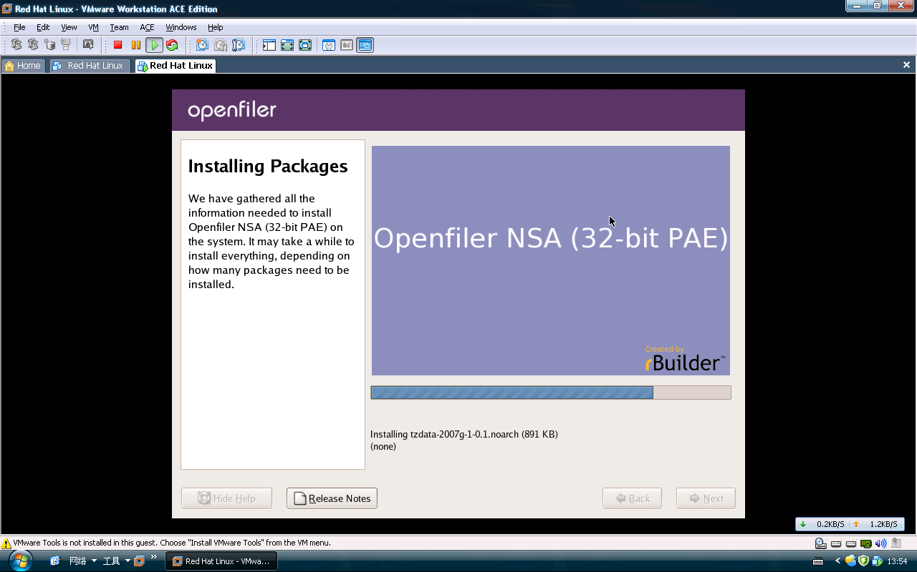
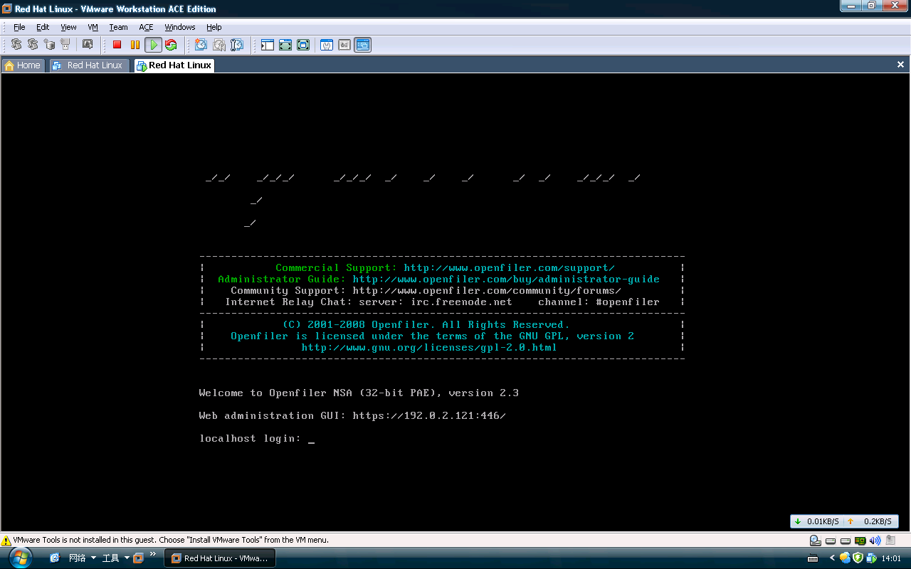
使用 Openfiler 配置 iSCSI 卷
在网络存储服务器 (openfiler1) 上执行以下配置任务！
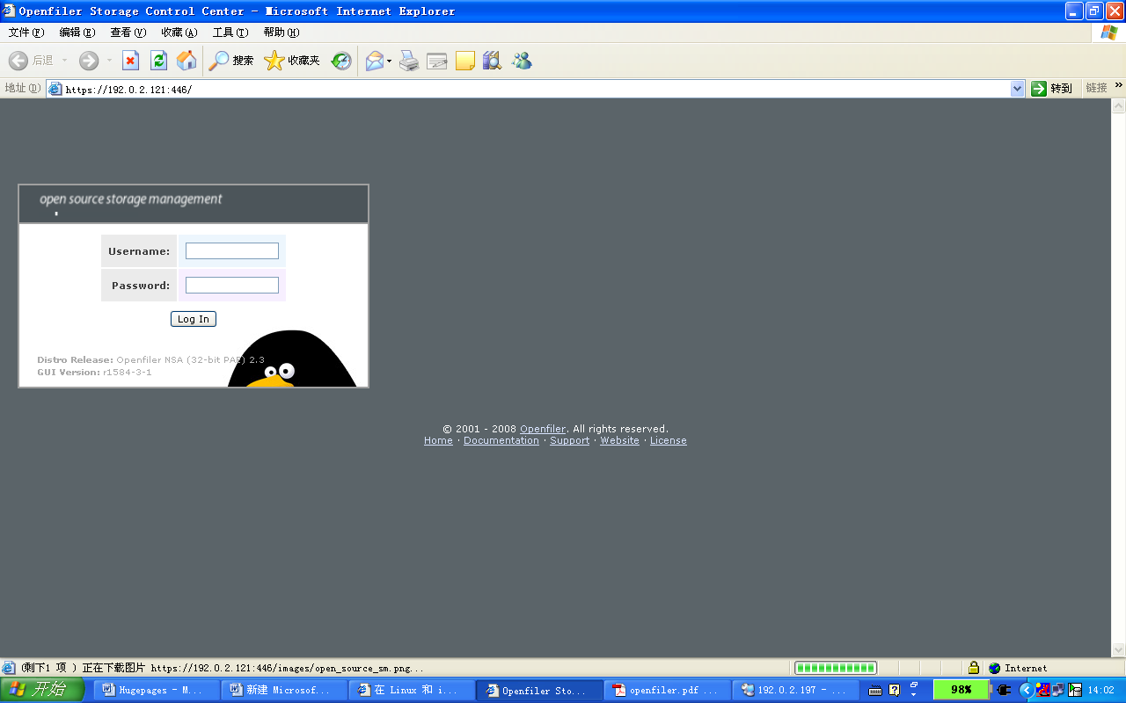
可以使用 Openfiler Storage Control Center（一个基于浏览器的工具，通过端口 446 上的 https 连接实现）执行 Openfiler 管理。https://openfiler1:446/
从 Openfiler Storage Control Center 主页，以管理员身份登录。Openfiler 的默认管理员登录凭证为：
Username： openfiler
Password: password
服务开启必须的服务
要启用 iSCSI 服务，单击“iSCSI target”服务名称下面的“Enable”。之后，“iSCSI target”状态应更改为“Enabled”。
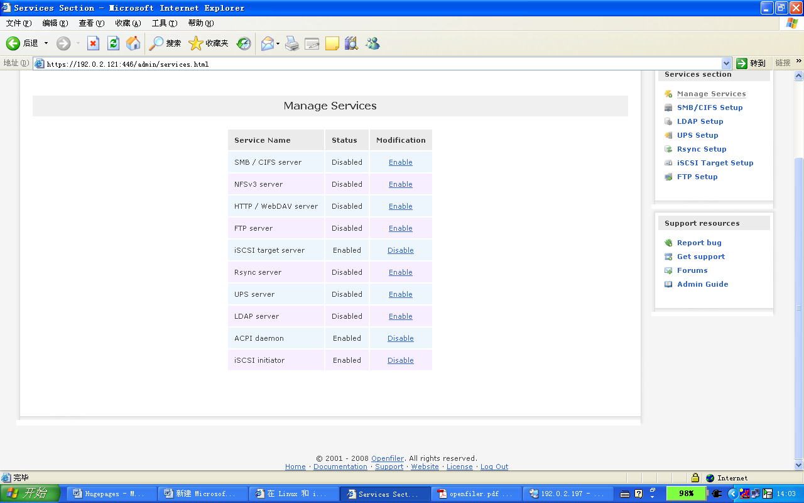
ietd 程序将实现 iSCSI Enterprise Target 软件的用户级部分，以便在 Linux 上构建 iSCSI 存储系统。启用 iSCSI 目标之后，我们应该能够通过 SSH 进入 Openfiler 服务器，并看到 iscsi-target 服务正在运行：
Last login: Wed Apr 6 08:52:15 2011 from 192.0.2.157
[root@test ~]# service iscsi-target status
ietd (pid 2753) is running...
[root@test ~]#
[root@test ~]#
网络访问限制
下一步是配置 Openfiler 中的网络访问，使两个 Oracle RAC 节点（linux1 和 linux2）都有权通过存储（专用）网络访问我们的 iSCSI 卷

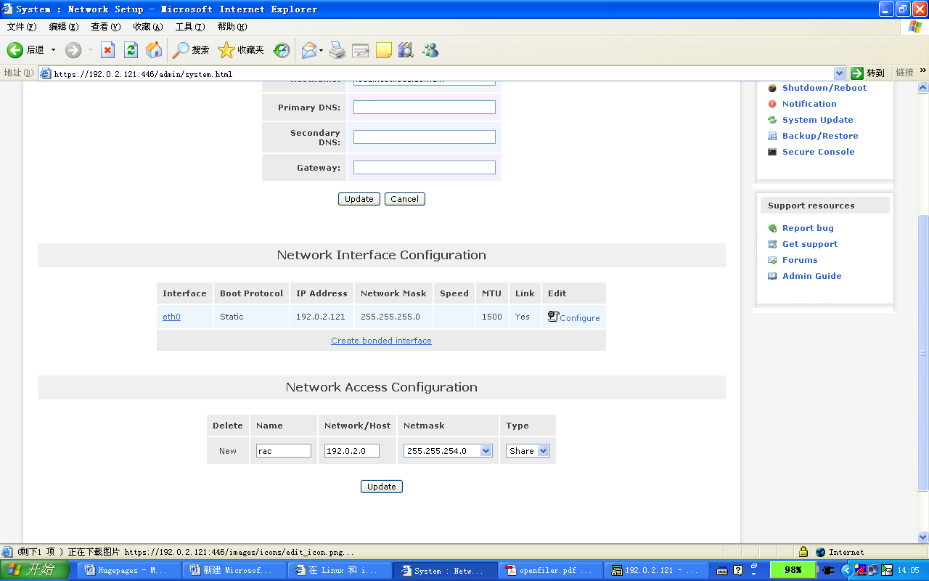
对物理磁盘进行分区
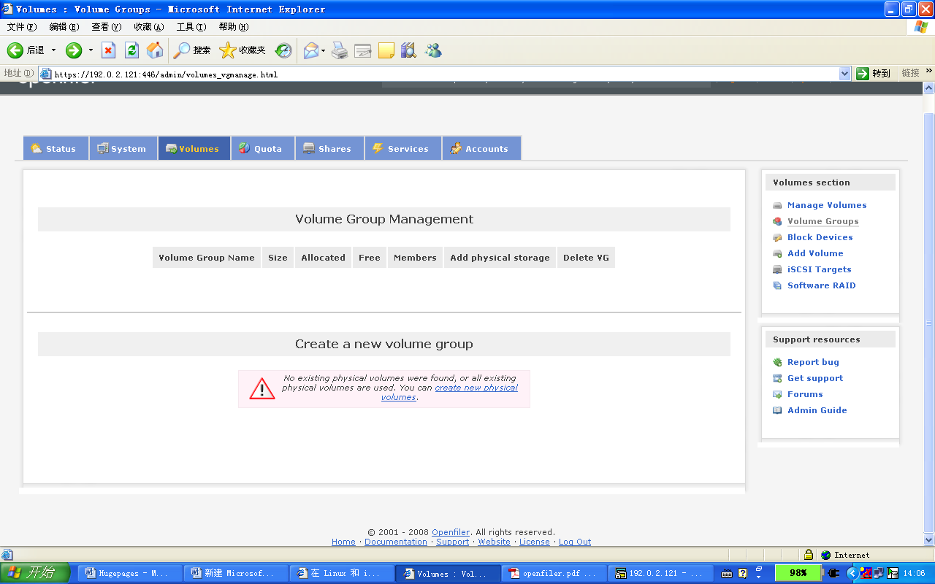
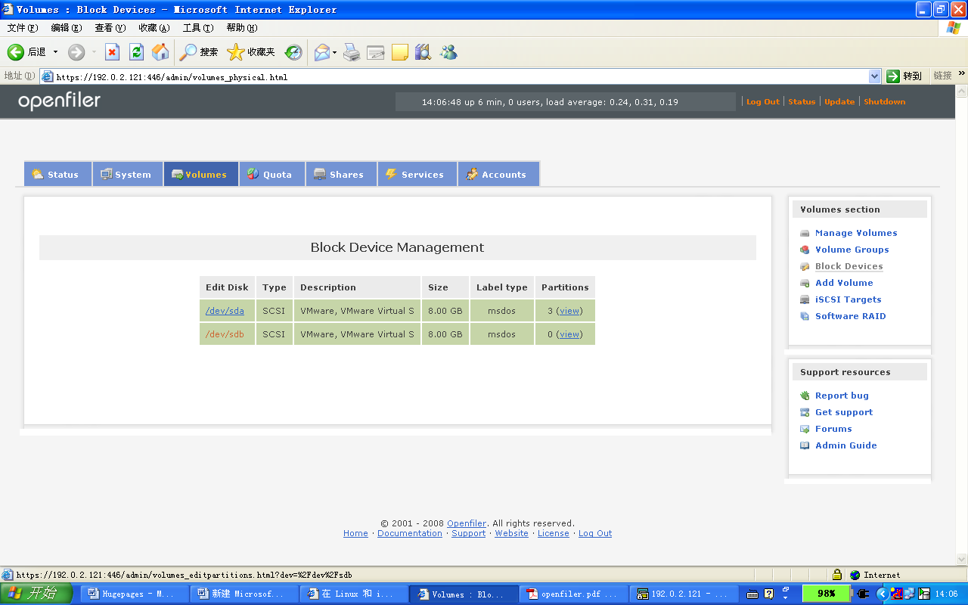
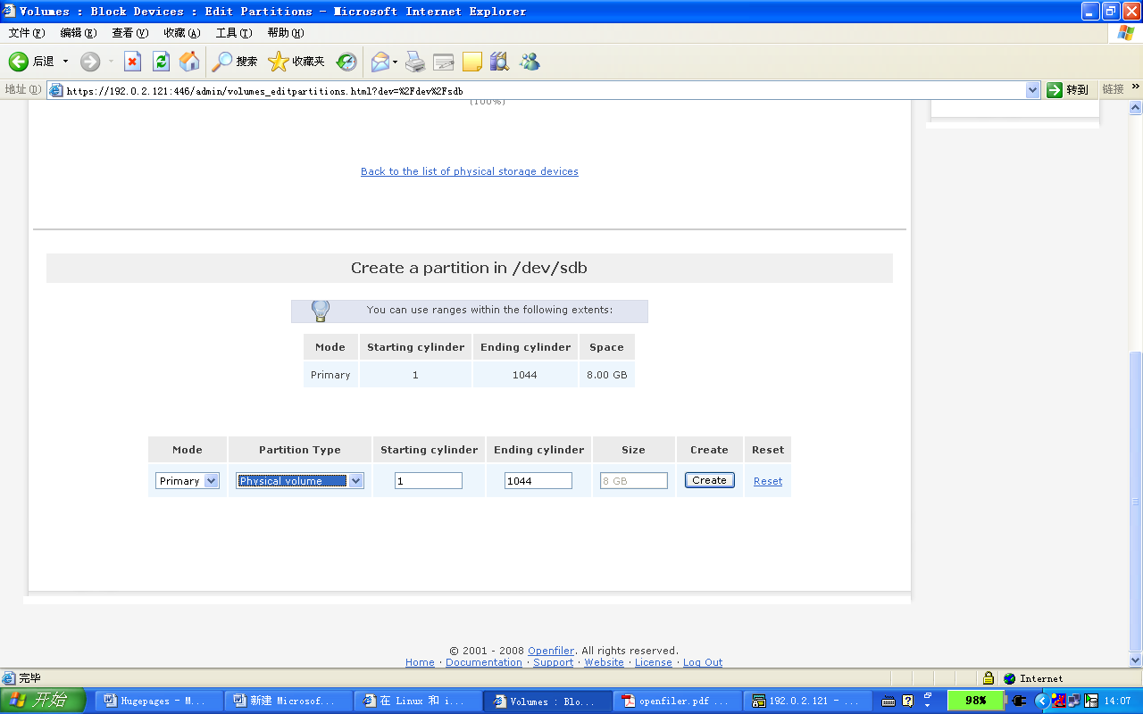
卷分组管理

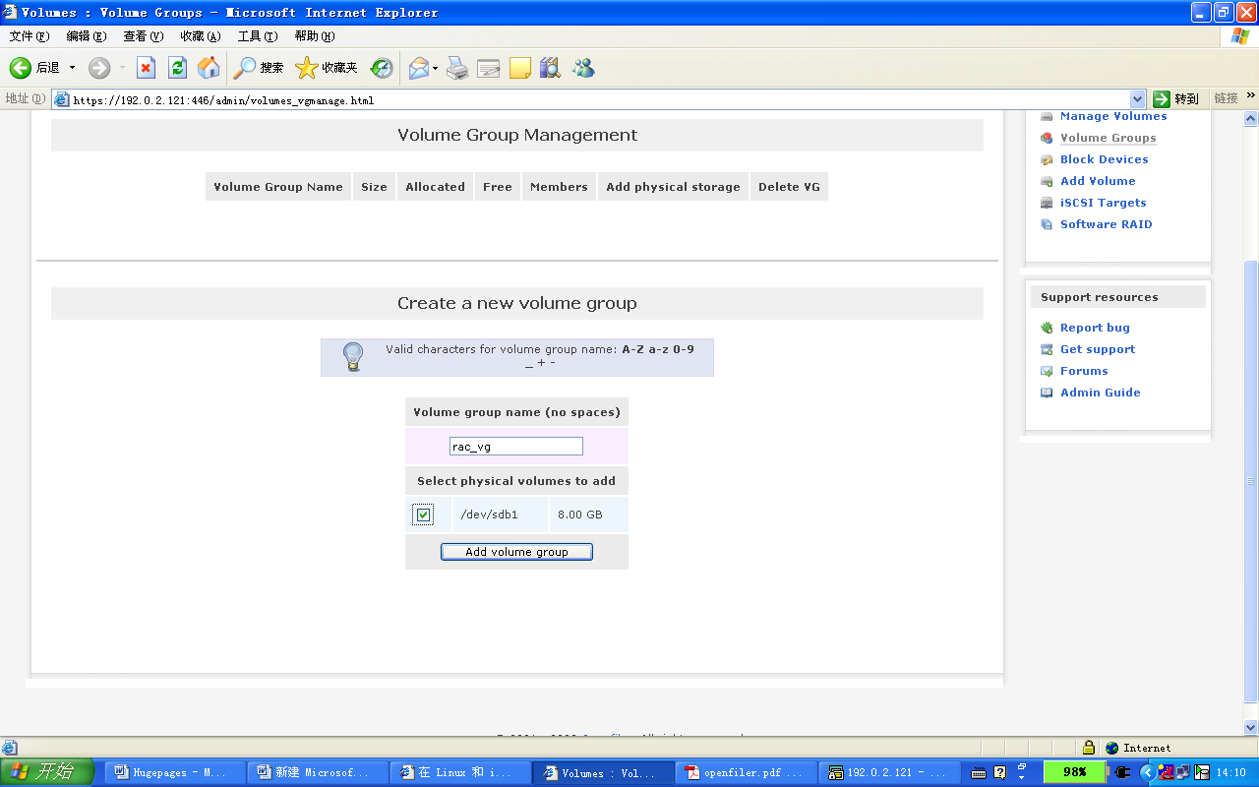
创建逻辑卷
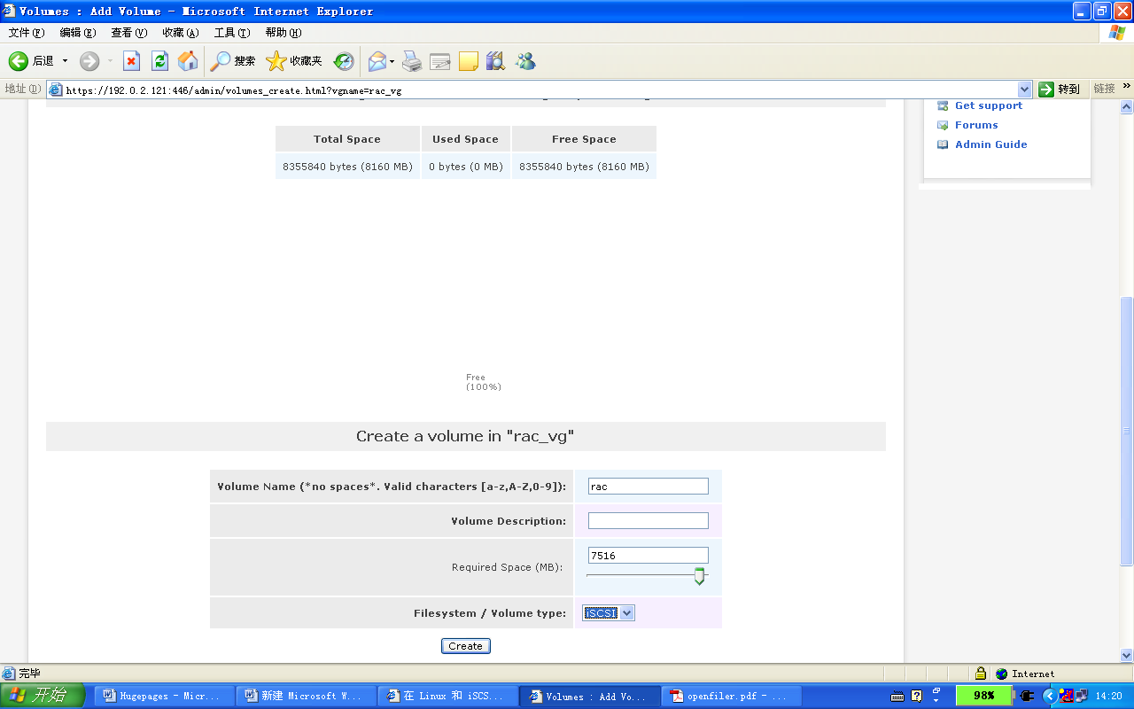
建立一个iSCSI 目标
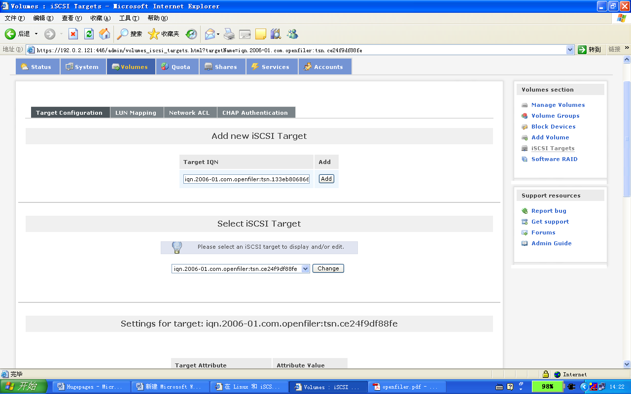
建立的volume 和 Target IQN 建立MAP
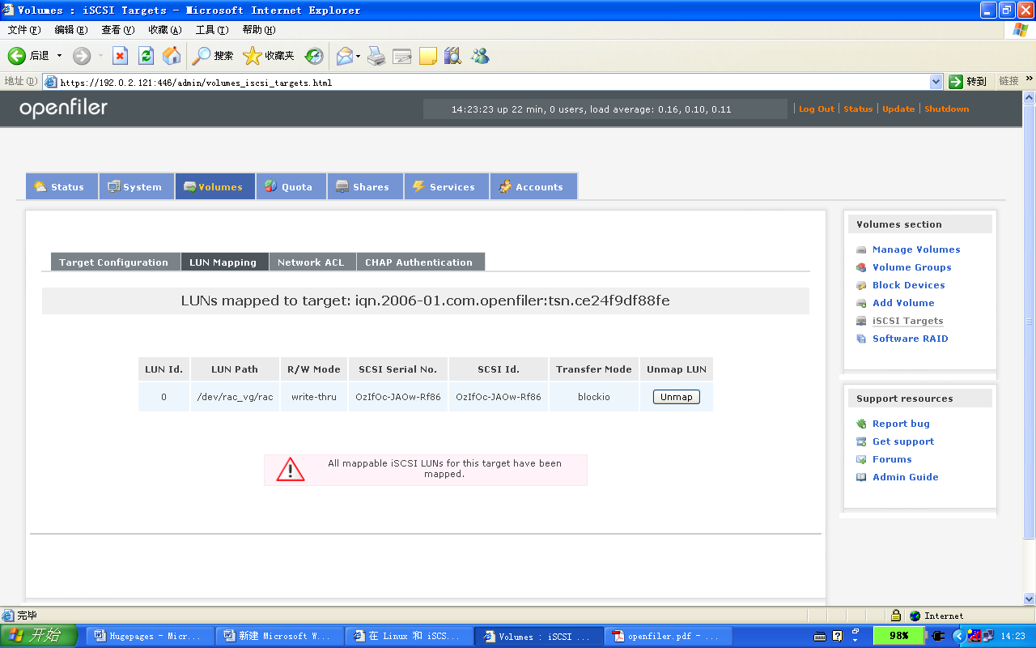
为新的逻辑卷授予访问权限
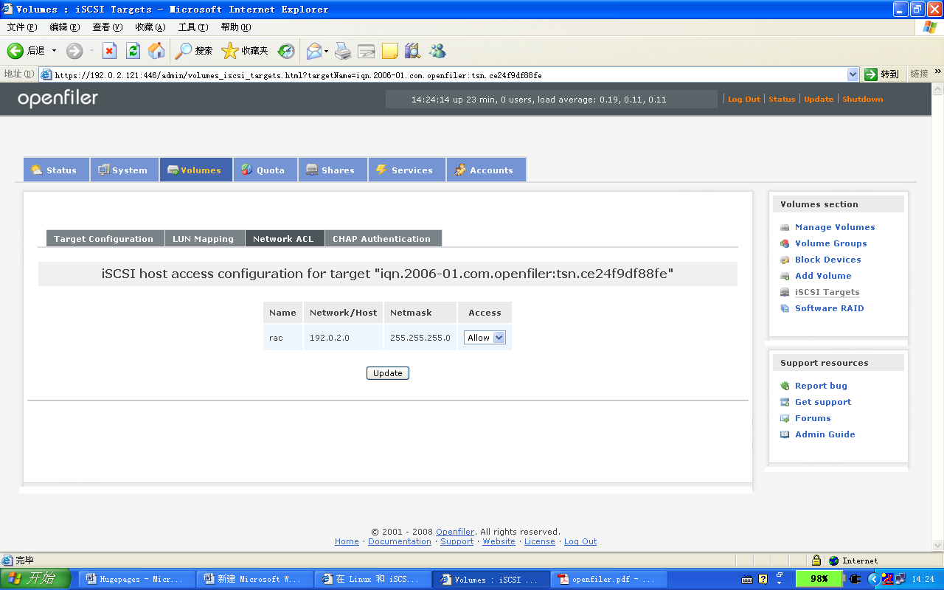
在 Oracle RAC 节点上配置 iSCSI 卷
Redhat5下initiator安装
RHEL 5已开始在内核中加入了对iSCSI的支持，使用的iSCSI Initiator软件是Open-iSCSI Initiator，支持万兆网卡
安装并配置iSCSI initiator
# iscsi-initiator-utils-6.2.0.871-0.10.el5.i386.rpm
warning: iscsi-initiator-utils-6.2.0.742-0.5.el5.i386.rpm: Header V3 DSA signature: NOKEY, key ID 37017186
Preparing... ########################################### [100%]
1:iscsi-initiator-utils ########################################### [100%]
chkconfig设置这两个服务在系统运行级别为3和5时随系统启动而启动
# chkconfig iscsi --level 35 on
# chkconfig iscsid --level 35 on

用vi编辑/etc/iscsi/initiatorname.iscsi文件，文件内容如下
InitiatorName= iqn.2006-01.com.openfiler:tsn.ce24f9df88fe3
本例中InitiatorName设置为iqn.2006-01.com.openfiler:tsn.ce24f9df88fe 需要从存储管理界面上找
用service iscsi start启动iSCSI服务。
# service iscsi start
分配存储资源，在Linux上执行target的发现
# iscsiadm -m discovery -t sendtargets -p 192.0.2.121
# iscsiadm -m node -L all

查看存储
# fdisk -l

Disk /dev/sda: 73.4 GB, 73407868928 bytes
255 heads, 63 sectors/track, 8924 cylinders
Units = cylinders of 16065 * 512 = 8225280 bytes

Device Boot Start End Blocks Id System
/dev/sda1 * 1 13 104391 83 Linux
/dev/sda2 14 2563 20482875 8e Linux LVM
/dev/sda3 2564 8924 51094732+ 8e Linux LVM

Disk /dev/sdb: 16.9 GB, 16944988160 bytes
64 heads, 32 sectors/track, 16160 cylinders
Units = cylinders of 2048 * 512 = 1048576 bytes
其中Disk /dev/sdb:为iSCSI 卷
磁盘分区
使用fdisk /dev/sdb分区后
Disk /dev/sdb: 16.9 GB, 16944988160 bytes
64 heads, 32 sectors/track, 16160 cylinders
Units = cylinders of 2048 * 512 = 1048576 bytes

Device Boot Start End Blocks Id System
/dev/sdb1 1 1908 1953776 83 Linux
/dev/sdb2 1909 3816 1953792 83 Linux
/dev/sdb3 3817 5724 1953792 83 Linux
/dev/sdb4 5725 16160 10686464 83 Linux
新建裸设备
redhat 5中通过udev规则进行配置。编辑/etc/udev/rules.d/60-raw.rules
[root@nodeA ~]# more /etc/udev/rules.d/60-raw.rules
# Enter raw device bindings here.
#
# An example would be:
# ACTION=="add", KERNEL=="sda", RUN+="/bin/raw /dev/raw/raw1 %N"
# to bind /dev/raw/raw1 to /dev/sda, or
# ACTION=="add", ENV{MAJOR}=="8", ENV{MINOR}=="1", RUN+="/bin/raw /dev/raw/raw2 %M %m"
# to bind /dev/raw/raw2 to the device with major 8, minor 1.
ACTION=="add", KERNEL=="sdb1", RUN+="/bin/raw /dev/raw/raw1 %N"
ACTION=="add", KERNEL=="sdb2", RUN+="/bin/raw /dev/raw/raw2 %N"
ACTION=="add", KERNEL=="sdb3", RUN+="/bin/raw /dev/raw/raw3 %N"
ACTION=="add", KERNEL=="sdb4", RUN+="/bin/raw /dev/raw/raw4 %N"
ACTION=="add", KERNEL=="raw[1-4]", OWNER=="oracle", GROUP=="oinstall", MODE=="0660"

重启服务：
# start_udev

[root@nodeA ~]# ls -l /dev/raw
crw-rw---- 1 oracle oinstall 162, 1 04-13 14:48 raw1
crw-rw---- 1 oracle oinstall 162, 2 04-13 14:48 raw2
crw-rw---- 1 oracle oinstall 162, 3 04-13 08:55 raw3
crw-rw---- 1 oracle oinstall 162, 4 04-13 08:55 raw4

6 配置ASM
下载包oracleasmlib-2.0.2-1.i386.rpm，上传到/root下
# rpm -ivh oracleasmlib-2.0.2-1.i386.rpm
Preparing...
########################################### [100%]
1:oracleasmlib
########################################### [100%]
检查已安装的ASM 程序包。
# rpm -qa | grep oracleasm
oracleasm-support-2.0.3-2 --安装系统时选择安装
oracleasm-2.6.9-42.0.0.0.1.ELsmp-2.0.3-2 --安装系统时选择安装
oracleasmlib-2.0.2-1 --已经手动安装
注意安装时一定对应好系统内核参数，否则会安装失败，此外安装时可能会提示需要各种rpm尤其是kernel相关的，建议之前就将所有kernel开头的rpm装好
在两个节点用root用户执行/etc/init.d/oracleasm configure，将默认用户设为oracle、用户组设为dba
在其中任一节点执行如下命令：
/etc/init.d/oracleasm createdisk VOL1 /dev/sdb3
/etc/init.d/oracleasm createdisk VOL2 /dev/sdb4
这样就会生成disk VOL1和VOL2

7 安装集群就绪服务

7.1 安装过程
执行以下任务来安装 Oracle CRS：
#/mnt/crs/runcluvfy.sh stage -post rac -n nodeA,nodeB -verbose
/mnt/crs/runInstaller
指定主目录详细信息 按如下所示设置名称和路径：
名称: OraCrs10g_home
路径:/oracle/crs
产品特定的先决性检查 检查通过
指定集群配置 集群名称：crs
集群节点：
公共节点名 专用节点名 虚拟主机名
nodeA nodeA-priv nodeA-vip
nodeB nodeB-priv nodeB-vip
指定网络接口用法 接口名称 子网 接口类型
eth0 192.0.2.0 公用
eth1 10.10.17.0 专用
指定集群注册表（Oracle Cluster Registry）位置 选择外部冗余
指定OCR位置: /home/oracle/shared_config/ocr
指定表决磁盘（Voting Disk）位置 选择外部冗余
指定表决磁盘位置: /home/oracle/shared_config/votingdisk
概要 选择安装
执行配置脚本 在 RAC 集群的每个节点上以“root”用户帐户打开一个新的控制台窗口。运行以下命令
/u01/app/oracle/oraInventory/orainstRoot.sh
/u01/app/oracle/product/10.2.0/crs_1/root.sh
注意要在 RAC 集群的所有节点上依次逐个运行，您在所有节点上运行 root.sh 时将收到多个警告。可以忽略这些警告，没什么问题。
如果设定的eth0为私有地址并提示执行root.sh失败的话，需要在控制台窗口以root用户运行/u01/app/oracle/product/10.2.0/crs_1/bin/vipca，配置虚拟地址。
返回 OUI 并确认此对话框窗口。
安装结束 安装结束时，退出 OUI。

7.2 详细安装过程
[oracle@nodeA /]$ /mnt/clusterware/runInstaller
Starting Oracle Universal Installer...
Checking installer requirements...
Checking operating system version: must be redhat-3, SuSE-9, redhat-4, UnitedLinux-1.0, asianux-1 or asianux-2
Passed
All installer requirements met.
Preparing to launch Oracle Universal Installer from /tmp/OraInstall2008-12-27_09-14-46PM. Please wait ...[oracle@nodeA /]$ Oracle Universal Installer, Version 10.2.0.1.0 Production
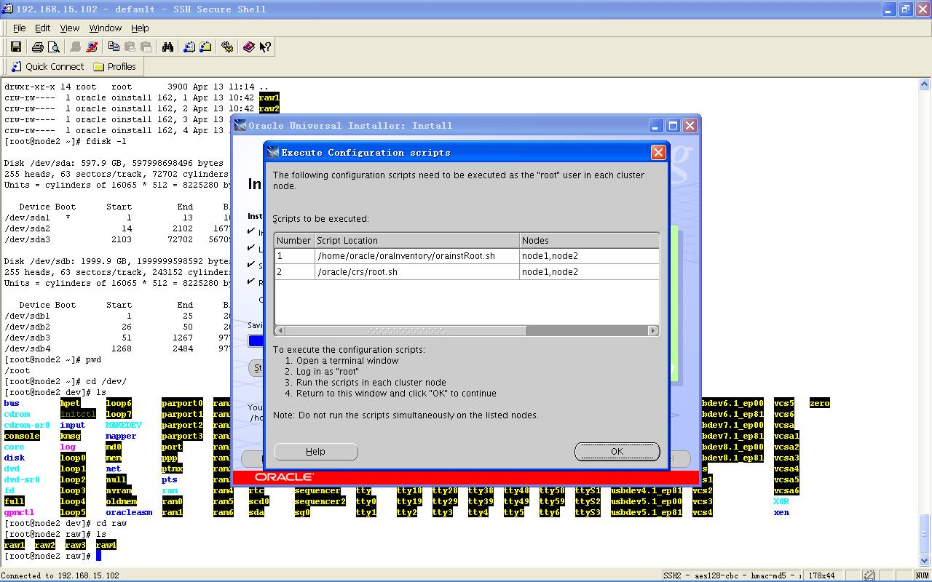
安装完毕后按提示在两个节点上分别执行orainstRoot.sh和root.sh脚本：
Copyright (C) 1999, 2005, Oracle. All rights reserved.在nodeA执行下列命令
#/u01/app/oracle/oraInventory/orainstRoot.sh
[root@nodeB raw]# /u01/app/oracle/oraInventory/orainstRoot.sh
Changing permissions of /u01/app/oracle/oraInventory to 770.
Changing groupname of /u01/app/oracle/oraInventory to oinstall.
The execution of the script is complete在nodeB执行下列命令
#/u01/app/oracle/oraInventory/orainstRoot.sh
[root@nodeB raw]# /u01/app/oracle/oraInventory/orainstRoot.sh
Changing permissions of /u01/app/oracle/oraInventory to 770.
Changing groupname of /u01/app/oracle/oraInventory to oinstall.
The execution of the script is complete
在nodeA执行下列命令
[root@nodeA bin]# /u01/app/oracle/product/10.2.0/crs_1/install/rootconfig
Checking to see if Oracle CRS stack is already configured
Setting the permissions on OCR backup directory
Setting up NS directories
Oracle Cluster Registry configuration upgraded successfully
WARNING: directory '/u01/app/oracle/product/10.2.0' is not owned by root
WARNING: directory '/u01/app/oracle/product' is not owned by root
WARNING: directory '/u01/app/oracle' is not owned by root
WARNING: directory '/u01/app' is not owned by root
WARNING: directory '/u01' is not owned by root
assigning default hostname nodeA for node 1.
assigning default hostname nodeB for node 2.
Successfully accumulated necessary OCR keys.
Using ports: CSS=49895 CRS=49896 EVMC=49898 and EVMR=49897.
node <nodenumber>: <nodename> <private interconnect name> <hostname>
node 1: nodeA nodeA-priv nodeA
node 2: nodeB nodeB-priv nodeB
Creating OCR keys for user 'root', privgrp 'root'..
Operation successful.
Now formatting voting device: /dev/raw/raw3
Now formatting voting device: /dev/raw/raw4
Now formatting voting device: /dev/raw/raw5
Format of 3 voting devices complete.
Startup will be queued to init within 90 seconds.
Adding daemons to inittab
Expecting the CRS daemons to be up within 600 seconds.
CSS is active on these nodes.
nodeA
CSS is inactive on these nodes.
nodeB
Local node checking complete.
Run root.sh on remaining nodes to start CRS daemons.
在nodeB执行下列命令
[root@nodeB lib]# /u01/app/oracle/product/10.2.0/crs_1/root.sh
WARNING: directory '/u01/app/oracle/product/10.2.0' is not owned by root
WARNING: directory '/u01/app/oracle/product' is not owned by root
WARNING: directory '/u01/app/oracle' is not owned by root
WARNING: directory '/u01/app' is not owned by root
WARNING: directory '/u01' is not owned by root
Checking to see if Oracle CRS stack is already configured
Setting the permissions on OCR backup directory
Setting up NS directories
Oracle Cluster Registry configuration upgraded successfully
WARNING: directory '/u01/app/oracle/product/10.2.0' is not owned by root
WARNING: directory '/u01/app/oracle/product' is not owned by root
WARNING: directory '/u01/app/oracle' is not owned by root
WARNING: directory '/u01/app' is not owned by root
WARNING: directory '/u01' is not owned by root
clscfg: EXISTING configuration version 3 detected.
clscfg: version 3 is 10G Release 2.
assigning default hostname nodeA for node 1.
assigning default hostname nodeB for node 2.
Successfully accumulated necessary OCR keys.
Using ports: CSS=49895 CRS=49896 EVMC=49898 and EVMR=49897.
node <nodenumber>: <nodename> <private interconnect name> <hostname>
node 1: nodeA nodeA-priv nodeA
node 2: nodeB nodeB-priv nodeB
clscfg: Arguments check out successfully.
NO KEYS WERE WRITTEN. Supply -force parameter to override.
-force is destructive and will destroy any previous cluster
configuration.
Oracle Cluster Registry for cluster has already been initialized
Startup will be queued to init within 90 seconds.
Adding daemons to inittab
Expecting the CRS daemons to be up within 600 seconds.
CSS is active on these nodes.
nodeA
nodeB
CSS is active on all nodes.
Waiting for the Oracle CRSD and EVMD to start
Waiting for the Oracle CRSD and EVMD to start
Waiting for the Oracle CRSD and EVMD to start
Oracle CRS stack installed and running under init(1M)
Running vipca(silent) for configuring nodeapps
The given interface(s), "eth0" is not public. Public interfaces should be used to configure virtual IPs.
如果出现上面的提示那么需要手动运行vipca命令来配置vip，即在第二个节点上执行vipca，而后只要输入nodeA-vip，IP配置会自动带出
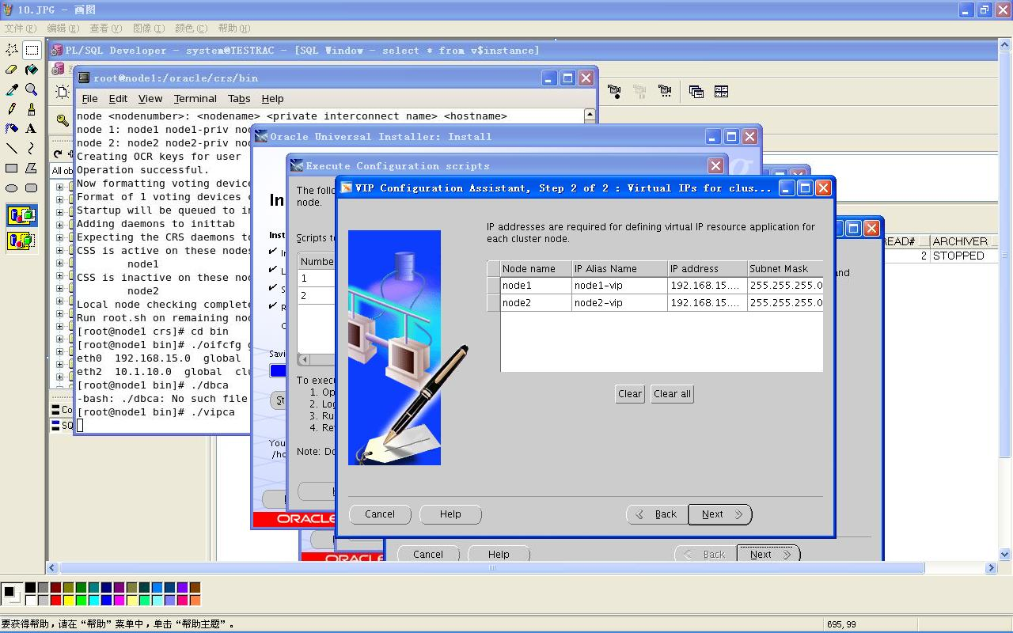
在第二个节点执行root.sh前建议手工修改/oracle/crs/bin下面的vipca和srvctl，否则可能报错：
修改vipca文件
[root@node2 opt]# vi /opt/ora10g/product/10.2.0/crs_1/bin/vipca
找到如下内容：
Remove this workaround when the bug 3937317 is fixed
arch=`uname -m`
if [ "$arch" = "i686" -o "$arch" = "ia64" ]
then
LD_ASSUME_KERNEL=2.4.19
export LD_ASSUME_KERNEL
fi
#End workaround
在fi后新添加一行：
unset LD_ASSUME_KERNEL

以及srvctl文件
[root@node2 opt]# vi /opt/ora10g/product/10.2.0/crs_1/bin/srvctl
找到如下内容：
LD_ASSUME_KERNEL=2.4.19
export LD_ASSUME_KERNEL
同样在其后新增加一行：
unset LD_ASSUME_KERNEL

8 安装 Oracle 数据库 10g 软件

8.1 安装过程
使用以下命令安装 Oracle 数据库 10g 软件：
/mnt/database/runInstaller
屏幕名称 回应
欢迎使用 单击 下一步
选择安装类型 选择 定制
指定主目录详细信息 按如下所示设置名称和路径：
名称: OraDb10g_home1
路径: /u01/app/oracle/product/10.2.0/db_1
指定硬件集群安装模式 选择 集群安装 选项，然后选择所有可用节点。单击 全选 选择所有服务器：nodeA和 nodeB。
如果安装此时停止，且有 RAC 节点的状态显示为“Node not reachable”（无法访问节点），则执行以下检查：
确保 CRS 正在所讨论节点上运行。
确保您能够从执行安装的节点访问所讨论的节点。
可用产品组件 选择 全部组件
产品特定的先决性检查 检查通过
特权操作系统组 OSDBA组：dba
OSOPER组: oper
创建数据库 仅安装数据库软件
概要 选择安装
执行配置脚本 安装完成时，将提示您运行 root.sh 脚本。需要记住的是，需要在 RAC 集群的所有节点上依次逐个（从运行数据库安装的节点开始）运行 root.sh 脚本。
/u01/app/oracle/product/10.2.0/db_1/root.sh
安装结束 安装结束时，退出 OUI。

8.2 详细安装过程
[oracle@nodeA racg]$ /mnt/database/runInstaller
Starting Oracle Universal Installer...
Checking installer requirements...
Checking operating system version: must be redhat-3, SuSE-9, redhat-4, UnitedLinux-1.0, asianux-1 or asianux-2
Passed
All installer requirements met.
Preparing to launch Oracle Universal Installer from /tmp/OraInstall2008-12-28_12-13-46AM. Please wait ...[oracle@nodeA racg]$ Oracle Universal Installer, Version 10.2.0.1.0 Production
Copyright (C) 1999, 2005, Oracle. All rights reserved.
oracle安装后，要求执行root.sh（全部节点执行)
NODEA执行
[root@nodeA bin]# /u01/app/oracle/product/10.2.0/db_1/root.sh
Running Oracle10 root.sh script...
The following environment variables are set as:
ORACLE_OWNER= oracle
ORACLE_HOME= /u01/app/oracle/product/10.2.0/db_1
Enter the full pathname of the local bin directory: [/usr/local/bin]:
Copying dbhome to /usr/local/bin ...
Copying oraenv to /usr/local/bin ...
Copying coraenv to /usr/local/bin ...
Creating /etc/oratab file...
Entries will be added to the /etc/oratab file as needed by
Database Configuration Assistant when a database is created
Finished running generic part of root.sh script.
Now product-specific root actions will be performed.
NODEB执行
[root@nodeB /]# /u01/app/oracle/product/10.2.0/db_1/root.sh
Running Oracle10 root.sh script...
The following environment variables are set as:
ORACLE_OWNER= oracle
ORACLE_HOME= /u01/app/oracle/product/10.2.0/db_1
Enter the full pathname of the local bin directory: [/usr/local/bin]:
Copying dbhome to /usr/local/bin ...
Copying oraenv to /usr/local/bin ...
Copying coraenv to /usr/local/bin ...
Creating /etc/oratab file...
Entries will be added to the /etc/oratab file as needed by
Database Configuration Assistant when a database is created
Finished running generic part of root.sh script.
Now product-specific root actions will be performed.
安装后提示管理信息
The following J2EE Applications have been deployed and are accessible at the URLs listed below.
iSQL*Plus URL:
http://nodeA:5560/isqlplus
iSQL*Plus DBA URL:
http://nodeA:5560/isqlplus/dba

9. 建库
在nodeA 执行netca命令创建监听
[oracle@nodeA ~]$ netca
Oracle Net Services Configuration:
Configuring Listener:LISTENER
Default local naming configuration complete.
nodeA...
nodeB...
Listener configuration complete.
Oracle Net Services configuration successful. The exit code is 0
在节点nodeA dbca 建库，运行$ORACLE_HOME/bin下面的dbca
在建库之前先选择最后一项存储管理，配置asm，选择双节点，而后要求设置sys和system密码，而后会提示是否创建asm instance选择是，创建instance后出现界面要求创建diskgroup，选择create new，起名rac_disk，选择/dev/raw/raw3和/dev/raw/raw4来创建，创建后会提示磁盘组已mount，点击finish
接下来选择创建数据库，正式建库：
同样选择双节点，选择数据库类型，这里以data warehouse为例，给定sid这里用的testrac，选择是否启动em选择不启动，选择数据存储类型，这里选择asm，要求选择diskgroup就选择刚建立的rac_disk，选择数据文件管理方式自然是自动管理，选择回复区和归档模式，这里暂时都不用，接下来选择内存配置，连接配置，字符集，process等等，如果都没问题就可以点击安装了，安装成功后会显示用户密码管理，可以更改密码或解锁用户，点退出即可。

至此集群数据库胜利安装完毕，恭喜

